Junit basic testing exercise

Exercise 1 : setting up Junit

Pom.xml
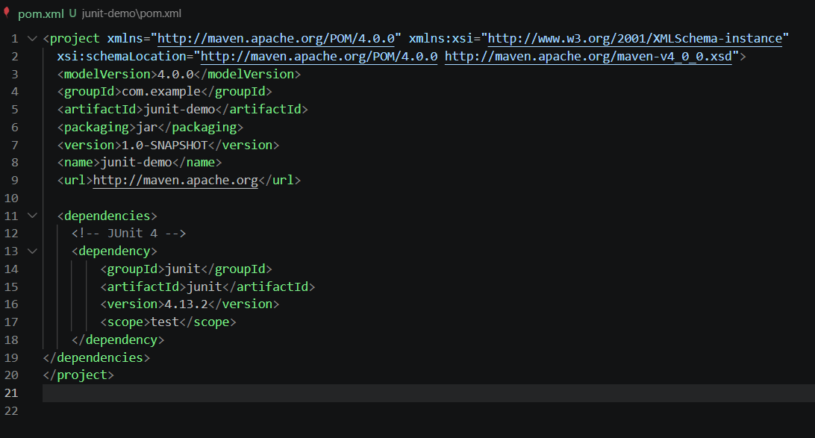

Created a sample test
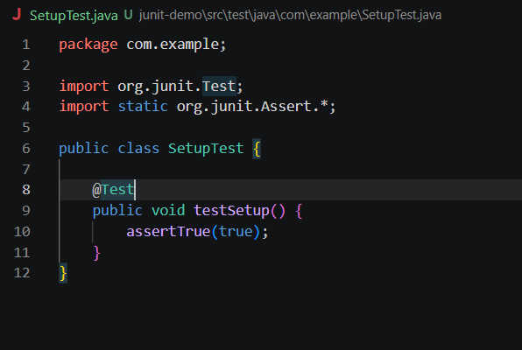

Run command

Result
